首先，去年卷子就给了这仨公式，所以其他的都要记！
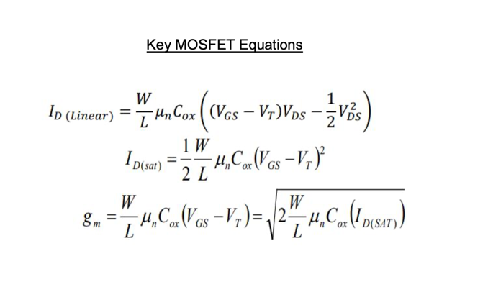
L2
• What is a p-n junction? p-n结（slide6）

If a piece of intrinsic silicon is doped so that part is n type and the other part is p type, a p-n junction is formed at the boundary between the two regions.

• The depletion region 耗尽层（Slide7）
After the p-n junction is formed, the region in the n region which loses free electrons form a layer of positive charges.

The region in the p region where holes are combining with electrons forms a layer of negative charges.

These two layers of charge form the depletion region.

• Majority and minority carriers (Silde8)
The depletion region is very thin (~1 𝜇 m) compared to the n and p segments. It acts as a barrier to the further movement of majority carriers.

The barrier potential is the potential difference that leads to the electric field across the depletion region. It is measured in volts (V). A certain amount of electric potential difference equal to the barrier potential (and the correct polarity) must be applied to a p-n junction before electrons can flow across the junction.

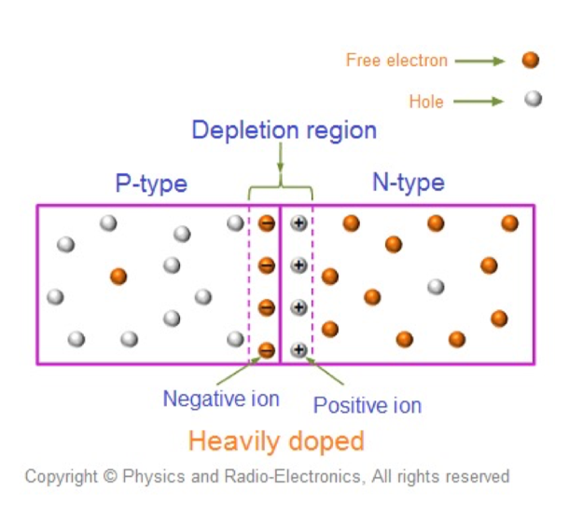

• Forward bias and reverse bias 正向偏置&反向偏置(Silde12-15)
When a forward bias voltage is applied to a p-n junction, the potential barrier of the p-n junction is lowered allowing electrons and holes to flow across the depletion region. When holes flow from the p-type material across the p-n junction into the n-type material they will then become minority carriers in the n-region. They will also be replenished by the positive terminal of the battery as they diffuse into the n-region. Similarly, when electrons flow from the n-type material across the p-n junction into the p-type material they will then become minority carriers in the p-region. They will also be replenished by the negative terminal of the battery connected to the n-type material and a major diffusion of electrons to the p-region takes place.
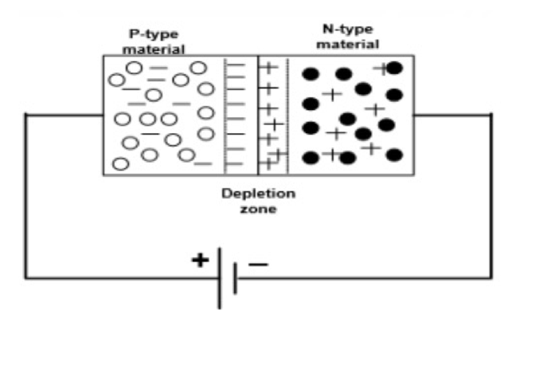
The negative potential will cause holes in the p-type material to move away from the junction and towards the contact which will result in more exposed negative acceptor ions and thus creating a wider depletion zone. Similarly, the positive potential will cause electrons in the n-type material to move away from the junction and towards the contact which will result in more exposed positive donor ions, and thus creating a wider depletion zone on the n side as well.

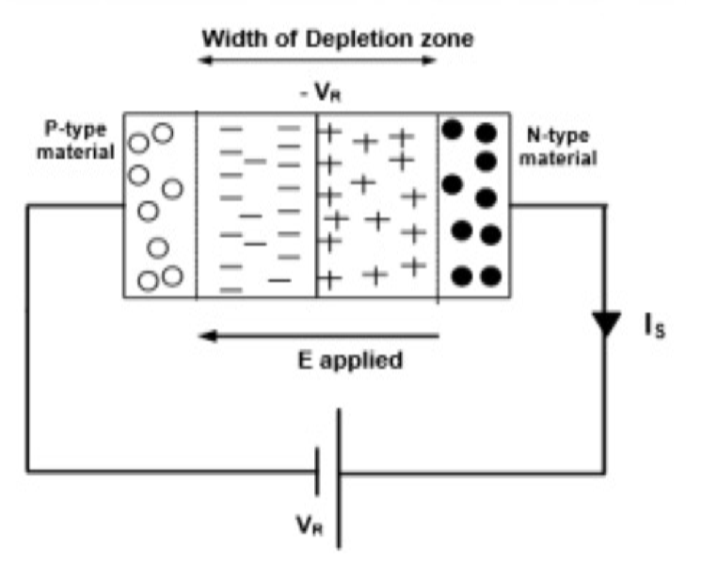

• Principles of operation of a p-n junction diode (自己写的)
PN junction can conduct electricity through forward voltage, often called conduction; And when the reverse voltage is not conductive, often called cutoff.

PN junction has unidirectional conductivity.

PN结通过正向电压时可以导电，称为导通；而加反向电压时不导电，常称为截止。
这说明：PN结具有单向导电性。

• Diode equation （第一个公式，要记吧）
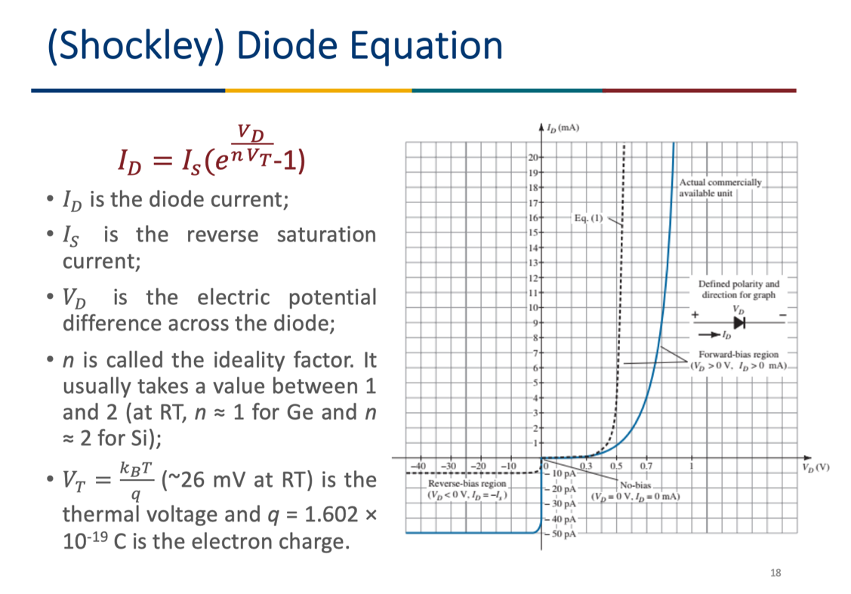

L3
• Differences between FETs and BJTs（重点 Slide21）
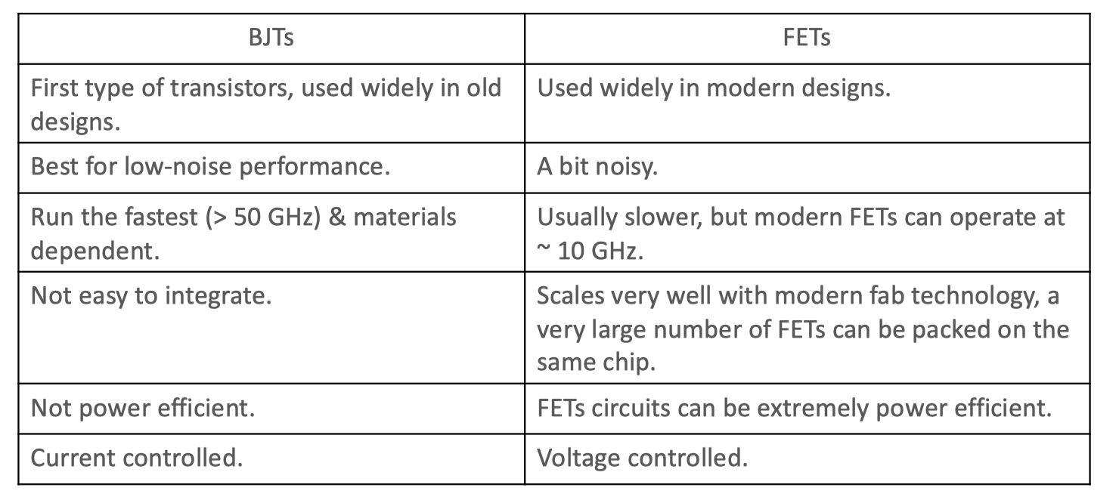

• Three terminals of JFETs （了解即可 Silde27-29）
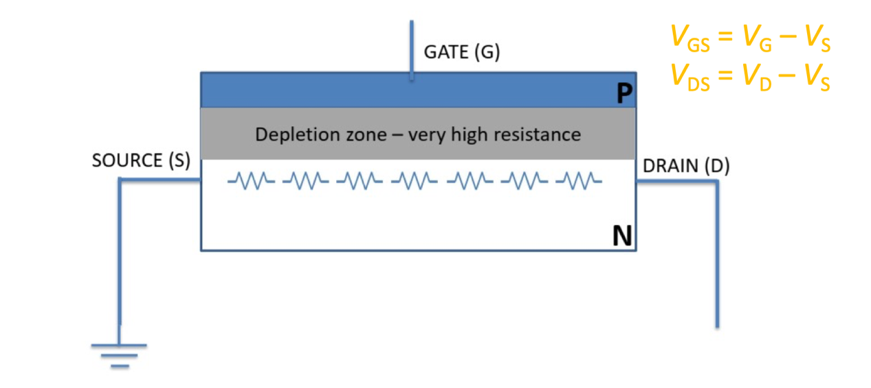

• Principles of operation of JFETs (自己写的)
When Vds is low, JFET channel presents a resistance characteristic, namely resistance work area. At the same time, the drain current basically increases linearly with the increase of voltage Vds, but the drain current increases square (^2) with the increase of gate voltage Vgs.

When the Vds is further increased, the channel is first clipped at the drain end, and the drain current reaches its maximum and is saturated (the saturation current search depends on the resistance of the channel that is not clipped). This is the saturation amplification region of the JFET, in which the JFET appears as a constant current source.

当Vds较低时，JFET的沟道呈现为电阻特性，即电阻工作区，这时漏极电流基本上随着电压Vds的增大而线性上升，但漏极电流随着栅极电压Vgs的增大而平方(^2)增大；

进一步增大Vds时，沟道即首先在漏极一端被夹断，则漏极电流达到最大而饱和（饱和电流搜大小决定于没有被夹断的沟道的电阻），这就是JFET的饱和放大区，这时JFET呈现为一个恒流源。

• I-d & V-ds plot (two operation regions)
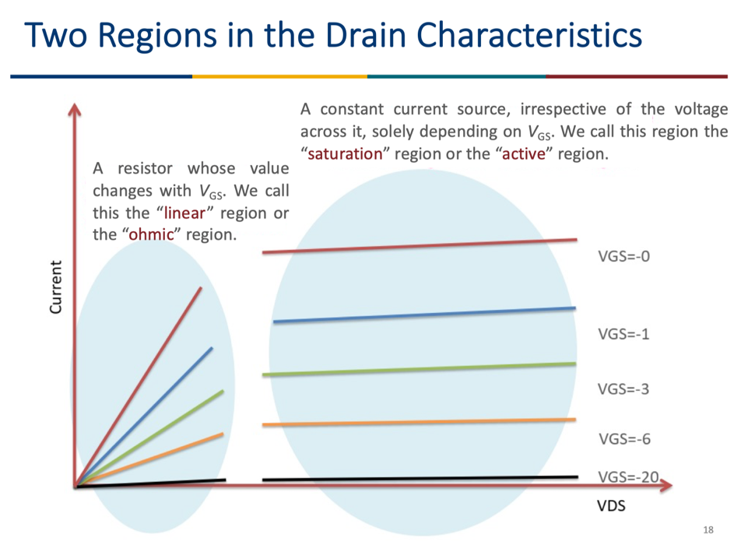

• Shockley’s transistor equation （第二个公式，要记）
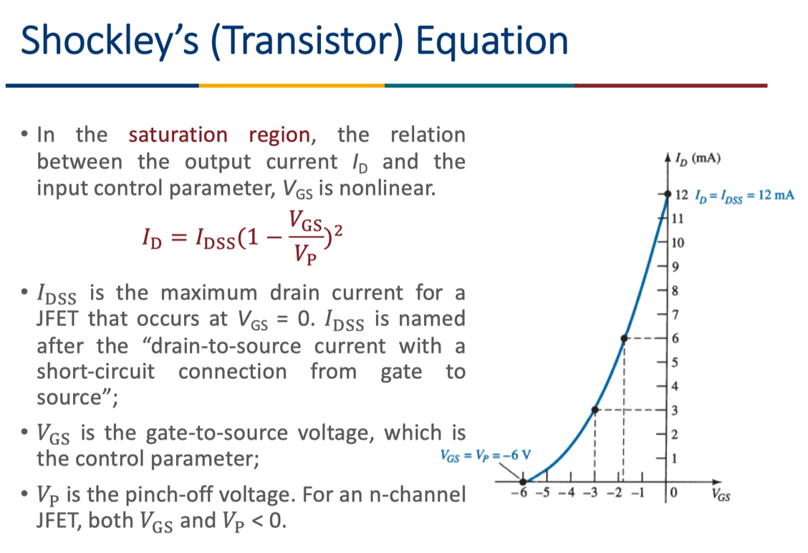
• Transfer curves (I-d & V-gs in the saturation region) 饱和区
